

**Format No. QSP/7.1/01.F01 (B) Issue No. 05, Rev. No. 5, Dated: Jan 1, 2017**

**UNIVERSITY OF PETROLEUM & ENERGY STUDIES**

**College of Engineering Studies**

**Dehradun**

**LAB PLAN**

Programme : B. Tech. CSE spl. in Mobile Application Development

Course :Mobile App Using Android Lab

Subject Code : CSMC 2107

No. of Credits : 1

Semester : III

Session : July, 2019 – December, 2019

Batch : 2018 - 2022

Prepared by : Ved Prakash Bhardwaj

Email :vpbharadwaj@ddn.upes.ac.in

**Approved By**

_______________________ _______________________

Faculty HOD

UPES Campus Tel: +91-135-2770137

“Energy Acres” Fax: +91 135- 27760904

P.O. Bidholi, Via Prem Nagar Website: [www.upes.ac.in](http://www.upes.ac.in)

Dehradun

**A. PRE-REQUISITES**

* Basic Java programming knowledge.
* Basic XML knowledge.

**B. PROGRAM OUTCOMES (POs) for B.Tech. CSE spl. in Mobile Application Development**

After completion of the program the student will be able to:

|  |  |  |  |  |  |  |  |  |  |  |  |  |  |  |  |  |
| --- | --- | --- | --- | --- | --- | --- | --- | --- | --- | --- | --- | --- | --- | --- | --- | --- |
|  |  | Engineering Knowledge | Problem analysis | Design development of solutions | Conduct investigations of complex problems | Modern tool usage | The engineer and society | Environment and sustainability | Ethics | Individual or team work | Communication | Project management and finance | Life-long Learning | System and application programming | Software development and management methodologies | Ability to understand and apply graphical tools and modeling algorithms to design games and animations.  management and apply these understanding in IT enabled e-commerce industry to optimize the processing channel and providean effective decision making support. |
| Course Code | Course Title | PO1 | PO2 | PO3 | PO 4 | PO 5 | PO6 | PO 7 | PO8 | PO9 | PO 10 | PO 11 | PO12 | PSO1 | PSO2 | PSO3 |
| CSEB  479 | Mobile App Development Using Android | 2 | 1 | 2 |  | 1 |  |  |  |  |  |  | **1**  ---- | **2** | **2** | **3** |

1=weakly mapped

2= moderately mapped

3=strongly mapped

**C. OBJECTIVES OF COURSE**

* The student should be able to design and code the programs using java concept.
* The student should be able to understand the flexibility and modularity provided by OOPs using Java.

**D. COURSE OUTCOMES (COs)**

Upon completion of this course the learners will be able to:

CO1: Learn the pre-requisite software installation process and IDE setup of Android Studio.

CO2: Implement basic concepts of Android app development using Java and XML.

CO3: Implement and execute programs, which are required for the e-commerce mobile

application development from end to end.

CO4: Implement persistent data storage by sing SQLite.

**Table: Correlation of POs vs. COs**

|  |  |  |  |  |  |  |  |  |  |  |  |  |  |  |  |
| --- | --- | --- | --- | --- | --- | --- | --- | --- | --- | --- | --- | --- | --- | --- | --- |
| CO/PO | PO1 | PO2 | PO3 | PO4 | PO5 | PO6 | PO7 | PO8 | PO9 | PO10 | PO11 | PO12 | PSO1 | PSO2 | PSO3 |
| CO1 | 1 |  |  |  | 2 |  |  |  |  |  |  | 1 | 1 | 2 | 3 |
| CO2 | 1 |  | 2 |  |  |  |  |  |  |  |  | 1 | 1 | 2 | 3 |
| CO3 | 1 | 1 | 2 |  |  |  |  |  |  |  |  | 1 | 1 | 2 | 3 |
| CO4 | 1 |  | 2 |  |  |  |  |  |  |  |  | 1 | 1 | 2 | 3 |

**E. COURSE OUTLINE**

|  |  |  |
| --- | --- | --- |
| **Expt. No.** | **Big Ideas/ Topics** | **Modality** |
| 1 | **Installation of Android Studio and its supporting JDK, SDK and Simulator** | F2F |
| 2 | **To Understand the Android studio IDE, Application Project hierarchy, different components of the hierarchy and execute “Hello World” and observe it on simulator** | F2F |
| 3 | **Program to demonstrate Activity Life Cycle on Android and to check how it varies on various mobile models using Simulator of Android studio** | F2F |
| 4 | **Program to demonstrate Intent, different types of intent ie., Explicit intent and Implicit intent** | F2F |
| 5 | **Program to demonstrate different Layouts (Linear, Relative, Grid, Table) using layout managers** | F2F |
| 6 | **Program to demonstrate various** UI **controls in android by creating an application.** | F2F |
| 7 | **Program to demonstrate Date picker and Time spinner in the application and display information with toaster** | F2F |
| 8 | **Program to demonstrate Spinners to the Registration form with toaster** | F2F |
| 9 | **Program to demonstrate Progress dialog, Custom dialog and Notifications.** | F2F |
| 10 | **Program to demonstrate Persistent data storage using SQLLite.** | F2F |
| 11 | **Program to demonstrate a home screen widget and demonstrate widget configuration** | F2F |

**F. PEDAGOGY**

In continuation to problem description, the solution to the given problem statement should be designed suitably using algorithm/flow-chart/pseudocode. After obtaining a successful design, the design is implemented using java & XML language and tested with appropriate test cases (with an insight on Input/Output Data Constraints). Students are evaluated under two main categories (1) Performance (via efficient design and implementation) and record, and (2) Preparation of the student evaluated via viva-voce /quiz. The same is detailed in Section-E.

**G. COURSE COMPLETION PLAN**

|  |  |  |  |  |  |  |
| --- | --- | --- | --- | --- | --- | --- |
| No. of Experiments planned/taken | | No. of Activities planned/ conducted | | No. of Quizzes/ viva planned/ conducted | | % Labs Experiments completed |
| 11 |  | 11 |  | 2 |  |  |

One lab session = 120 min.

**H. EVALUATION & GRADING**

Students will be evaluated regularly/continuously throughout the course based on the following:

1. Performance & Record - 50%
2. Viva Voce or Quiz Examination - 50%

**H.1 Performance & Record:** WEIGHTAGE - 50%

11 lab Experiments are conducted face-to-face (F2F). The lists of activities performed under the experiments are detailed in Section-F. A sample template of the evaluation of lab activity is provided in the table below.

|  |  |  |  |  |
| --- | --- | --- | --- | --- |
|  | **Evaluation of each Lab Activity** | |  |  |
|  | Problem Description | 10% marks |  |  |
|  | Algorithm Design | 40% marks |  |  |
|  | Coding Syntax, Execution and Bug Fixing | 30% marks |  |  |
|  | I/O Test cases & Data Constraints | 10% marks |  |  |
|  | Records (submitted before the very next turn.) | 10% marks |  |  |

**H.2 Viva Voce or Quiz Examination:** WEIGHTAGE - 50%

The preparation of the students would be evaluated based on two viva-voce or quiz examinations in periodic schedules (each with 50% weightage).

It is mandatory for the students to attend the above said continuous evaluation. Students who do not attend will lose their marks. Continuous Internal Assessment Record Sheet will be displayed at the end of the semester.

**GRADING:**

The overall marks obtained at the end of the semester comprising the above two mentioned shall be converted to a grade.

Student(s), who have met the qualifying criteria of individual practical subject but not met qualifying criteria of SGPA, will not be allowed to re-appear for improvement. However, those students with Grade “F” and those who wish to re-appear in the practical subject shall be required to pay the prescribed fee per subject as notified by the University. These students will be eligible to *repeat continuous evaluation* of that respective practical subject(s) during summer vacation (June-July).

Grade shall be awarded on the performance of the student(s). The Grade will be capped as per the rules mentioned in student Bulletin. All Other rules and regulations such as requirement of passing, etc. will remain same as mentioned in rules & regulations.

Between 40 and 50 : PASS

Between 51 and 75 : MERIT

and above : DISTINCTION

**I. DETAILED DELIVERY PLAN**

**EXPERIMENT – 1**

**TITLE:** Introduction to Android Environment

1. Installation of JDK,SDK
2. Setting of path, classpath
3. Installing Android Studio.
4. Configuring and installing AVD(Android Virtual Device)

**EXPERIMENT – 2**

**TITLE:** Understanding Android IDE

1. Android Project building and project hierarchy components.
   1. App Manifest file
   2. Activity – Java Code
   3. Resources – Layout design using XML and Drag & Drop methods
2. Different tools and configuration parameters to integrate to various Android versions.
3. Android Mobile simulator, hardware virtual configuration understanding.
4. Understanding Debugging and its usage. Understanding Android OS/Application generated messages, filtering in Logcat.
5. Demonstrate “Hello World”.

**EXPERIMENT – 3**

**TITLE** Program to demonstrate Activity Life Cycle on Android and to check how it varies on various mobile models using Simulator of Android studio.

1. Write a program to demonstrate different stages of the Android application activity lifecycle, by which program has to implement below functions:
   1. onCreate()
   2. onStart()
   3. onResume()
   4. onPause()
   5. onStop()
   6. onRestart()
   7. onDestroy()
2. Generate messages and print using Log.d
3. Verify the messages in LogCat using appropriate filter

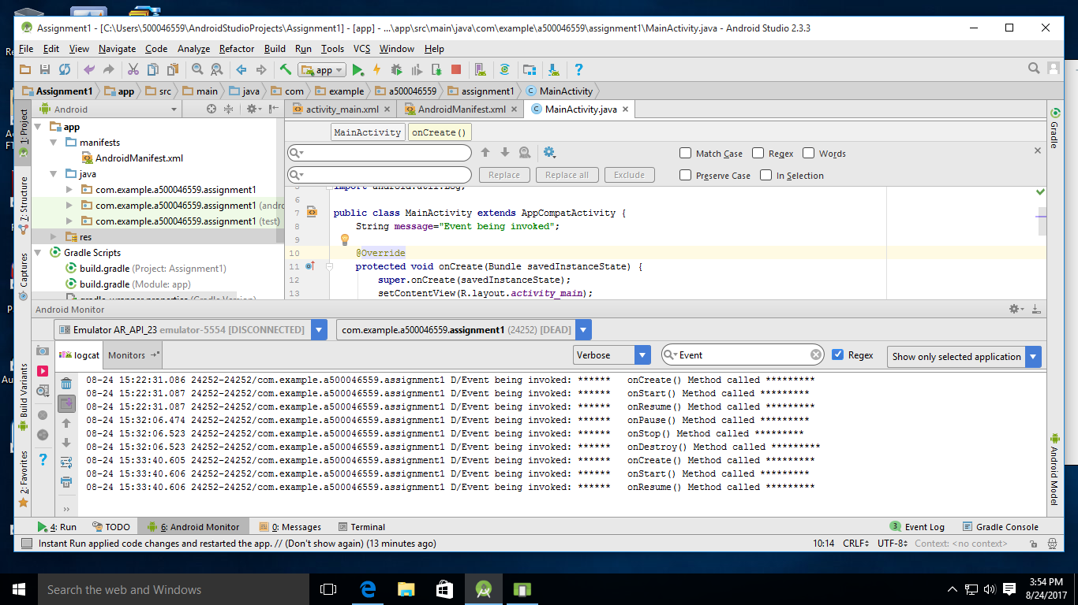

**EXPERIMENT – 4**

**TITLE:** Intents

1. Understand the usage of Intent Filter in Manifestfile.
2. Write a program to create an Implicit Intent there by invoking a browser and opening “google.com” website.
3. Write a program to create Explicit Intent to invoke another activity and vice versa.

**EXPERIMENT – 5**

**TITLE:** Layouts

1. Create a Linear Layout with an activity created as shown below where the controls in the page are linearly aligned.
2. Create a Relative Layout with an activity created as shown below where the controls in the page are Relatively aligned.

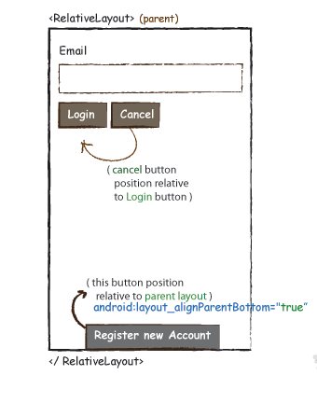

1. Create a Grid Layout with an activity created as shown below where the controls in the page are aligned in Grid.

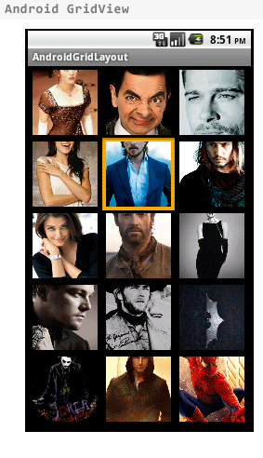

1. Create a Table Layout with an activity created as shown below where the controls in the page are aligned in table.

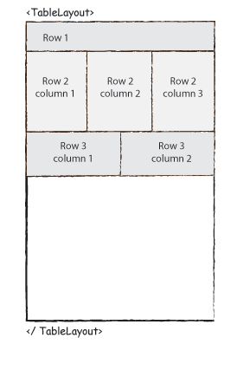

**EXPERIMENT – 6**

**TITLE: Program to demonstrate various** UI **controls in android by creating an online registration form application.**

1. Write a program in XML to create the activity for the online registration form
2. Write a Java program to display the entire information content filled in the form on to a toast when the submit button is clicked
3. 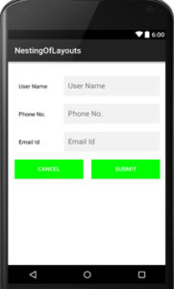Create a Registration Form with multiple fields using Nested Linear Layouts. For that, we set vertical orientation for parent Linear Layout and horizontal orientation for child Linear Layout. Placing buttons in the child linear layout.

**EXPERIMENT – 7**

**TITLE: Program to demonstrate Spinners, Date picker and Time Picker to the Registration form with toaster**

1. Write a program to incorporate the Date Picker and Time Picker in the previous demonstrated lab code.
2. Write relevant XML and java code to reflect the input controls (Date and Time picker) on the activity.

**EXPERIMENT – 8**

**TITLE: Program to demonstrate Spinners to the Registration form with toaster**

1. Include Country and State after Email field. Add 3(India, USA, Australia) countries and add at least 3 states for each Country spinner and State Spinner. After submit display the entire registration form information in the toaster.

**EXPERIMENT – 9**

**TITLE: Program to demonstrate Progress dialog, Custom dialog and Notifications.**

1. Write a Java code and relevant XML code for an activity to demonstrate progress dialog for a audio clip.
2. Write a Java code and relevant XML code with in the above activity with a Custom dialog and a

Notification.

**EXPERIMENT – 10**

**TITLE: Program to demonstrate Persistent data storage using SQLLite.**

**Or**

**Create a simple mobile application which is storing information of ten students.**

**Information like their Name, Roll No., and their result of last semester.**

1. Write a Java program to implement persistent data storage concept using in build SQLLite of android.
2. The implementation will be done for the earlier done registration froms data. Rather than showing the information on the toster, now it will be stored in the SQLLite and will be retrived with the appropriate UI design.
3. There will be another activity which will be called after the registration submit button, where the stored records will be displayed and for navigation purposes.

**EXPERIMENT – 11**

**TITLE: Program to demonstrate a home screen widget and demonstrate widget configuration**

1. Write a java code and the XML code for creating a widget .

**J. SUGGESTED READINGS:**

1. Android Application Development Black Book – Pradeep Kothari
2. Professional Android 4 Application Development 3rd Edition – Reto Meier
3. Programming Android O’ Rielly
4. https://developer.android.com/training/index.html

**K. GUIDELINES**

**Cell Phones and other Electronic Communication Devices:** Cell phones and other electronic communication devices (such as Blackberries) MUST be turned off during the lab session.

**E-Mail and online learning tool:** Each student in the class should have UPES e-mail id and a password to access the Blackboard regularly. The best way to arrange meetings with faculty or is by email and prior appointment. Various research papers/reference material will be mailed/uploaded on online learning platform time to time.

**Attendance:** Students are required to have **minimum attendance of 75%** in the subject.

**Passing criterion:** Student has to secure minimum 40% marks of the “highest marks scored by the student for the subject” in the total marks in order to pass in that paper.

**L. COURSE OUTCOME ASSESSMENT**

To assess the fulfilment of course outcomes two different approaches have been decided. Degree of fulfillment of course outcomes will be assessed in different ways through direct assessment and indirect assessment. In Direct Assessment, it is measured through Continuous assessments. Each assessment is designed in such a way that it can address one or two outcomes (depending upon the course completion). Indirect assessment is done through the student survey which needs to be designed by the faculty (sample format is given below) and it shall be conducted towards the end of course completion. The evaluation of the achievement of the Course Outcomes shall be done by analyzing the inputs received through Direct and Indirect Assessments and then corrective actions suggested for further improvement.

**Format for Indirect Assessment of Course Outcomes**

|  |  |
| --- | --- |
| NAME: |  |
| ENROLLMENT NO: |  |
| SAP ID: |  |
| COURSE: | Mobile Application Development using Android |
| PROGRAM: | B. Tech. CSE spl. in TI |

Please rate the following aspects of the Course Outcomes. Use the scale 1 to 4 *

|  |  |  |  |  |  |
| --- | --- | --- | --- | --- | --- |
| **S. No.** | **Course Outcomes** | **1** | **2** | **3** | **4** |
| CO1 | Understand the Installation process of Android Studio. |  |  |  |  |
| CO2 | Implement the fundamental concepts of Android app development using Java & XML. |  |  |  |  |
| CO3 | Develop mobile apps for real life problems using Android Studio. |  |  |  |  |
| CO4 | Implement persistent data storage by using SQLite. |  |  |  |  |

Very Good

4

3

Below Average

Average

Good

2

1

*

**Signature**